Sport New Zealand’s Vision and Mission

New Zealand has a population of just under 5 million. Life expectancy is 81.16 years. About half the population is physically active for at least 30 min per week. New Zealand sport lists almost 130 sports and pastimes.
Sport New Zealand’s vision is ``everyone. Every day – enjoying and excelling through sport and recreation.’’
To realise this vision Sport New Zealand’s mission is to create a sport and recreation environment where more New Zealanders participate, support and win.
As the leader of the single sport system, Sport New Zealand has four priority areas -- young New Zealanders, community sport, recreation, and partner capability.
Sport NZ will continue to place importance on National Sports Organisations for their strategic leadership role, especially in building and maintaining competitive sporting pathways and talent development. It is anticipated that NSOs will continue to be key partners.
Coaching Structure Foundation Coaches, Development coaches Performance Coaches and High Performance Coaches
Lots of info on the Sport New Zealand website including a coach starter pack and distance learning materials. Nationally accredited Vocational Qualification and University undergraduate courses.
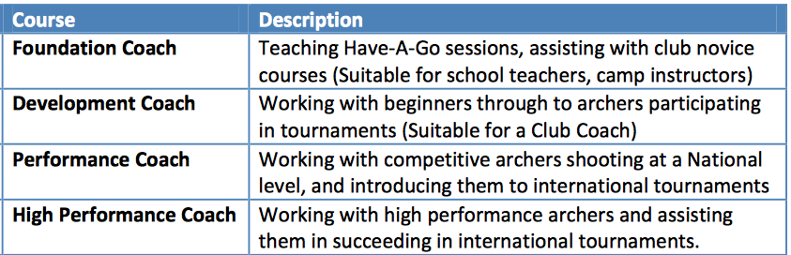
Development Courses through Sport New Zealand and World Archery
Handball looking for an unpaid national coach nothing on their website about coaching
Strength and condition offer high performance unpaid internships for 10 months as 16 hour per week work experience in four NZ centres.
Funding for foundation coach training is via charities or self-funding.

