**MSc in Clinical Trials Programme**

**Patient and Public Involvement in research course**

**Getting started with Pebble+**

# accessing Pebble+

* Click on the Pebble+ link within the relevant Moodle course or launch Pebble+ from [here](https://v3.pebblepad.co.uk/login/Login/ChooseInstall)
* If you have any problems launching Pebble+, make sure you have pop-ups enabled on your browser

# To create your Activity Log

**Note:** You only have to create one Activity Log for the semester. A new Activity Log is like a blank diary, ready for you to fill with records of your Activities.

* On the toolbar, click **Design New**, and then **Activity Log**

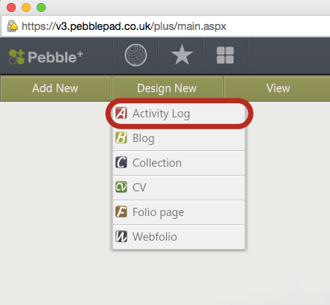

* A Properties window will open on the right side of your screen. Enter a title and description for the Activity Log, and the start date for your logging period.

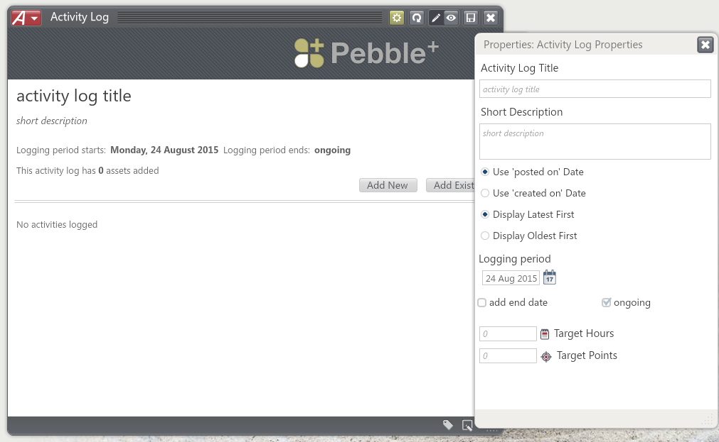

* Press the cross at the top right of the Properties window to close this for now
* Save the Activity Log using the  icon in the top right
* If you want to add an Activitystraight away, press the cross at the top right of the Activity Log, and follow step 3.

**Note:** Remember DO NOT select “Add New” from the Activity Log window as this will open up the wrong template to complete. If by mistake, you do select this, just select the cross on the top right of the Activity Log and continue to follow step 3.

# adding a REFLECTION

**Note:** It’s important to write down your thoughts as soon as possible after a relevant piece of activity, Adobe Connect tutorial, thought discussion, reading, or assignment, for example.

* From the main Pebble+ window, on the toolbar, click Add New, and then Reflection, Journal Entry
* Fill in the fields, reflecting on your learning experience and question your learning and development in relation to Patient and Public Involvement in research.
* At any point, you can edit, preview , or save your journal using the buttons at the top right of the Journal Entry window. Make sure your journal is saved before you close it.
* To close and add your Journal Entry in the Activity Log, select the cross at the top right of the Journal Entry window, and follow step 4.

1. **ADD to your Activity Log**

**Note:** Every time you use Pebble+, navigate back to your Activity Log. From there, you can add Reflections to it. These reflections are like entries in your diary.

* If you are not already in Pebble+, see Section 1: Accessing Pebble+
* On the toolbar, click **View**, and then **Assets**. A window entitled “Assets” will open. This is the Asset Store, where you can view items that you have created on Pebble+
* Select your Activity Log

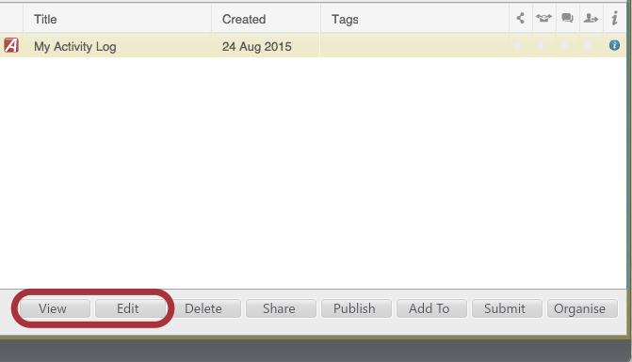

* From here you have several options. Both **View** and **Edit** will open your Activity Log. From within your Activity Log you can click **Add Existing** to add the Journal Entry you have just created.
* Select your Journal Entry from the list and select **Confirm** (if you are not sure if you have selected the correct journal entry, you can **View** this first before you upload to your activity log).
* You should now see your activity log, with the journal entry listed.

# Submitting your activity log

**Note:** Your Activity Log isn’t submitted until you follow these final steps.

* Instructions for submission will be notified on the announcement board nearer the time of the formative submission date (Friday, February 5th 2016).