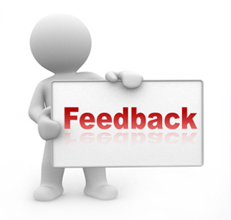

I’d like to have some of your thoughts from this course.

What is the most significant thing that you learned?

What did you enjoy?

What did you not enjoy?

How engaged did you feel with the subject matter, approach taken and assessments?

Any ideas for improvement?

What advice would you give a prospective student?

Anything else?